

Sample Business Plan

**Hair & Beauty Salon**

How to Use This Sample Plan

Edit this Google Doc version directly to fit your needs. **This copy is yours.**

This sample plan is a good way to get started, but as you know, you can’t just type in your details, print it, and turn it into the bank. Every business is unique, and your business plan should reflect that. Use this sample business plan as the starting point for your own plan and customize it to reflect your unique business.

What makes this sample plan unique?

* Each section includes **instructions and prompts** to help you think through, and clearly convey, the distinct details of your business.
* **Pro tips** **(noted in blue)** are based on our experience helping over a million business owners write their business plans. Consider these tips as you create your own plan.
* Writing your business plan is just one step in achieving your broader business goal. At the end of this template, you’ll find **next steps to help you achieve your goal *faster***.
* Because you downloaded this sample business plan—you get access to a discount on the #1 rated business plan builder, [LivePlan](http://www.liveplan.com/?offer=BUS_SAMPLE_HALFOFF&utm_source=bplans.com&utm_medium=download&utm_campaign=sample_plan&utm_content=hairsalon_docx_inline1), which is found throughout this template.

[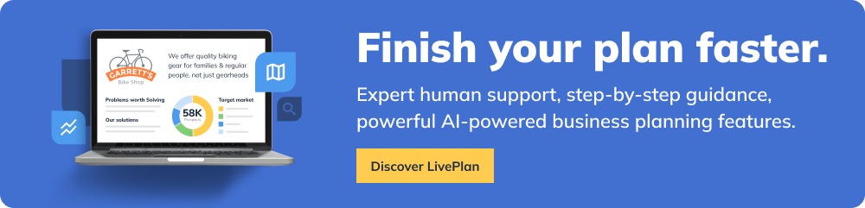](https://www.liveplan.com/?offer=BUS_SAMPLE_HALFOFF&utm_source=bplans.com&utm_medium=download&utm_campaign=sample_plan&utm_content=hairsalon_docx_ad1)

**Confidential**

**Trend Setters Hair Studio**

The Trend Begins Here

**Business Plan**

Prepared [date]

**Contact Information**

Jane Smith

jane@yourcompany.com

111.222.333

yourcompany.com

1234 Main St.  
Anywhere, OR 12345

**Table of contents**

**Executive Summary 1**

Introduction 1

Keys to success 2

**Company Summary 3**

Start-Up Summary 3

**Products & Services 6**

**Strategy & Implementation 7**

Competitive Edge 7

Marketing Strategy 8

Sales Forecast 8

Milestones 11

**Management Summary 12**

Personnel Plan 12

**Financial Plan 13**

Important Assumptions 13

Projected Cash Flow 14

Break-even Analysis 16

Projected Profit and Loss 18

Balance Sheet 22

Business Ratios 23

**Appendix 25**

# **Executive Summary**

| ⭐️**Pro tip:** We typically recommend you revisit this section after you’ve finished the rest of your business plan so that you can easily summarize what you’ve already written. |
| --- |

## Introduction

Trend Setters is a full-service beauty salon dedicated to consistently providing high customer satisfaction by rendering excellent service, using quality products, and furnishing an enjoyable atmosphere at an acceptable price/value relationship. We will also maintain a friendly, fair, and creative work environment that respects diversity, ideas, and hard work.

Our Mission

To supply services and products that enhance our clients' physical appearance and mental relaxation.

| ⭐**Pro tip:** Struggling with writer's block? Harness the power of [AI with LivePlan Assistant’s Suggestion feature](https://www.liveplan.com/features/ai-powered-liveplan-assistant?offer=BUS_SAMPLE_HALFOFF&utm_source=bplans.com&utm_medium=download&utm_campaign=sample_plan&utm_content=hairsalon_docx_inline2). Using your business name and industry details, LivePlan will generate suggestions for each part of your plan so that you’re never left staring at an empty template. |
| --- |

Our Motto

"The Trend Begins Here!"

The timing is right for starting this new venture. Patiently searching for six months for the perfect location, one was finally found. The demand from the owner's clients, as well as the ambitions of the owner to one day start her own salon, and the procurement of highly professional and qualified beauticians to support the salon, has made this business one of great potential.

Curly Comb, co-owner with Roller Comb, Jr., her husband, has worked in a prestigious, upscale salon in MyTown, Texas for the past two years. Curley has created a large client following through hard work and dedication. Curley, and her talented team of beauticians, has what it takes to make this venture an extremely successful one.

We expect our growing reputation to lead to new clients and beauticians to support our anticipated growth. To achieve our objectives, Trend Setters is seeking additional loan financing. This loan will be paid from the cash flow from the business, and will be collateralized by the assets of the company, and backed by the character, experience, and personal guarantees of the owners.

Chart: Highlights

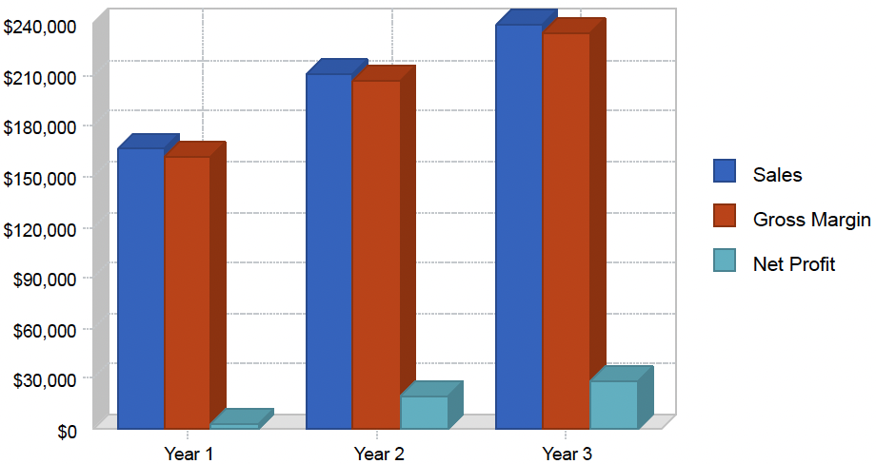

## Keys to success

The keys to success in our business are:

* Location: providing an easily accessible location for customers.
* Environment: providing an environment conducive to giving relaxing and professional service.
* Convenience: offering clients a wide range of services in one setting, and extended business hours.
* Reputation: reputation of the owner and other "beauticians" as providing superior personal service.

# **Company Summary**

Trend Setters will, upon commencement of operations, sell a wide range of beauty services and products. We will provide quality hair, nail, and skin services, along with top lines of beauty products. What will set Trend Setters apart from the competition is our commitment to providing all of these services in one convenient location.

The salon will be located in a retail strip mall at 1234 Stylish Road, MyTown. The salon will utilize 1,540 square feet. The location is strategically situated on one of the busiest streets in MyTown. It is a high profile area, with easy access from all parts of town.

# 

## 

## Start-Up Summary

After spending several months searching for a salon to purchase, the owners decided to start a salon from the ground up. The start-up capital will be used for the design, leasehold improvements, and equipment of the salon.

Leasehold improvements will amount to approximately $32,500, and salon equipment will cost about $27,000. The owner will invest $500 for cash-on-hand at starting date.

Table: Start-up Requirements

| **Start-up Expenses** |  |
| --- | --- |
| Rent deposit | $1,817 |
| Other | $0 |
| Total Start-up Expenses | $1,817 |
| **Start-up Assets** |  |
| Cash Required | $500 |
| Other Current Assets | $600 |
| Long-term Assets | $59,500 |
| Total Assets | $60,600 |
|  |  |
| **Total Requirements** | **$62,417** |

Table: Start-up Funding

| **Start-up Funding** |  |
| --- | --- |
| Start-up Expenses to Fund | $1,817 |
| Start-up Assets to Fund | $60,600 |
| Total Funding Required | $62,417 |
| **Assets** |  |
| Non-cash Assets from Start-up | $60,100 |
| Cash Requirements from Start-up | $500 |
| Additional Cash Raised | $0 |
| Cash Balance on Starting Date | $500 |
| **Liabilities** |  |
| Current Borrowing | $0 |
| Long-term Liabilities | $61,917 |
| Accounts Payable (Outstanding Bills) | $0 |
| Other Current Liabilities (interest-free) | $0 |
| Total Liabilities | $61,917 |
|  |  |
| **Capital** |  |
| Planned Investment |  |
| Owner | $500 |
| Investor | $0 |
| Additional Investment Requirement | $0 |
| Total Planned Investment | $500 |
|  |  |
| Loss at Start-up (Start-up Expenses) | ($1,817) |
| Total Capital | ($1,317) |
|  |  |
| Total Capital and Liabilities | $60,600 |
| **Total Funding** | **$62,417** |

Chart: Start-up

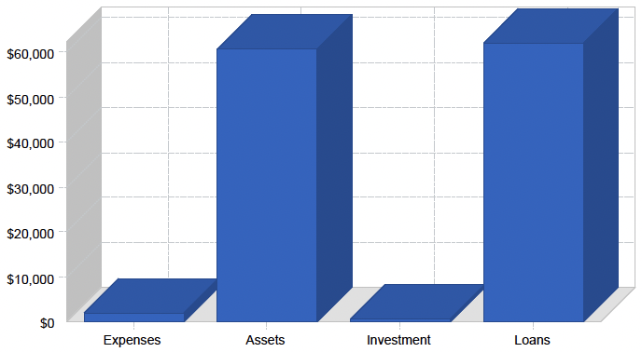

# **Products & Services**

Trend Setters is considered an upscale full-service beauty salon. We will offer a wide range of services that include:

Hair

* Cuts
* Relaxers
* Perms
* Colors
* Shampoo
* Conditioning
* Curling
* Reconstructing
* Weaving
* Waving

Nails

* Manicures
* Pedicures
* Polish
* Sculptured nails

Skin Care

* European facials
* Body waxing
* Massage

# **Strategy & Implementation**

Skilled at what we do, good customer service, and creating a pleasant environment for our customers will be important to implementing our business plan.

| ⭐**Pro tip:** Having a hard time defining what makes your business different from your competitors? First off, familiarize yourself with both your direct, and indirect competitors to get a feel for what they offer.  Then, think about these things: do you offer a unique price point? A unique set of features or product offerings? A unique experience? Are you, or your team, subject matter experts? Weave these points into your competitive edge. |
| --- |

## Competitive Edge

Trend Setters wants to set itself apart from other beauty salons that may offer only one or two types of services. Having come from such a salon, Curley has realized, from talking with her clients, that they desire all of the services that we are proposing, but they remain frustrated because they must get their hair done at one place, and nails done at another. Although the focus of Trend Setters is hair services, we do wish to offer our clients the convenience of these other services in one location.

There are a number of salons like ours, but they are mainly in the very high income parts of MyTown and surrounding areas. We do not intend to compete with these so called "Day Spas." We wish to offer a middle ground for clients who can't quite afford those high-end luxury salons.

Our business atmosphere will be a relaxing one where clients can kick back and be pampered. Soft drinks will be offered to clients as they enter for service. Televisions will be located in the waiting and hair-drying area.

| ⭐**Pro tip:** Still struggling? [LivePlan Assistant will generate ideas](https://www.liveplan.com/features/ai-powered-liveplan-assistant?offer=BUS_SAMPLE_HALFOFF&utm_source=bplans.com&utm_medium=download&utm_campaign=sample_plan&utm_content=hairsalon_docx_inline3) for how to better define your competitive edge. You can then insert these suggestions into your plan directly or continue to ideate until your value is perfectly documented. |
| --- |

## Marketing Strategy

Our marketing strategy is simple: satisfied clients are our best marketing tool. When a client leaves our business with a new look, he or she broadcasts our name and quality to the public. Most of our clients will be referrals from existing clients.

No major advertising campaigns are anticipated. Our research has shown that word of mouth is the best advertising for this type of business. We will, however, run specials throughout the week. We will also ask clients for referrals, and reward them with discounted or free services depending on the number of clients they bring.

We will also offer discounts to new clients who have been referred. There are plans for a lottery that will offer a free trip to, say, Cancun. A client would simply refer new clients to us, and we would place a card in a box for each client he or she brings. The more clients they bring, the more chances they have of winning the trip.

## Sales Forecast

We anticipate the highest peak in the months of November and December in our sales forecast, due to the holiday seasons. In November, there is Ramadan, and for non-muslim Malaysians and Indonesians, it means vacation time. Approximately 1.5 million Indonesians visit Singapore each year, mostly for shopping and dining. Then in December, we anticipate more tourists coming into Singapore; this explains the jump in sales over the last two months of the year.

| ⭐**Pro tip:** Starting a forecast for the first time? Simply start by creating a two column list. The first column just lists ways in which you’ll make money (or are already making money). These are your revenue streams and will go into your sales forecast. The second column lists costs or expenses you might incur. These can then be broken down into direct and indirect costs and used in your financial forecast as well.  Not sure how you’ll make money or what your expenses might be? [LivePlan Assistant’s Suggested Forecast Categories](https://www.liveplan.com/features/ai-powered-liveplan-assistant?offer=BUS_SAMPLE_HALFOFF&utm_source=bplans.com&utm_medium=download&utm_campaign=sample_plan&utm_content=hairsalon_docx_inline4) will generate suggestions for revenue streams, direct costs, personnel, and expenses specific to your business. |
| --- |

Sales Forecast

| **Sales** | **Year 1** | **Year 2** | **Year 3** |
| --- | --- | --- | --- |
| Owner | $49,600 | $57,040 | $65,696 |
| Stylist #1 | $49,600 | $57,040 | $65,596 |
| Barber #1 | $16,800 | $19,320 | $22,218 |
| Stylist #2 | $22,800 | $25,622 | $29,465 |
| Stylist #3 | $0 | $22,000 | $24,000 |
| Nails and massage | $18,000 | $20,000 | $22,000 |
|  |  |  |  |
| Product sales | $9,600 | $10,000 | $11,000 |
| Total Sales | $166,400 | $211,022 | $239,975 |
|  |  |  |  |
| **Direct Cost of Sales** | **Year 1** | **Year 2** | **Year 3** |
| Product Costs | $4,320 | $4,300 | $4,400 |
| Other | $0 | $0 | $0 |
| **Subtotal Direct Cost of Sales** | **$4,320** | **$4,300** | **$4,400** |

Sales Monthly

## 

Sales By Year

## 

## Milestones

The milestones table and chart show the specific detail about actual program activities that should be taking place during the year. Each one has its manager, starting date, ending date, and budget. During the year we will be keeping track of implementation against plan, with reports on the timely completion of these activities as planned.

| **Milestone** | **Start Date** | **End Date** | **Budget** | **Manager** | **Department** |
| --- | --- | --- | --- | --- | --- |
| Sample Milestones | January 4 | January 4 | $0 | Joe G. | Reception |
| Finish Business Plan | September 3 | October 3 | $100 | Roller C. | CEO |
| Acquire Financing | September 13 | November 2 | $200 | Curly C. | Co-CEO |
| Ah HA! Event | September 23 | September 28 | $60 | Marianne | Reception & Events |
| Ah Merde Alors! Event | October 23 | October 28 | $250 | Marionette | Reception & Events |
| Grand Opening | November 2 | November 7 | $500 | Marionette | Reception & Events |
| Marketing Program Starts | October 3 | October 28 | $1,000 | Dennis | Intern |
| Plan vs. Actual Review | February 28 | March 7 | $0 | Roller C. | CEO |
| First Break-even Month | July 7 | August 7 | $0 |  |  |
| Hire Employees | May 31 | June 30 | $150 | Curly C | Co-CEO |
| **Totals** |  |  | **$2,360** |  |  |

## 

## 

## 

# 

# **Management Summary**

Trend Setters will be organized and managed in a creative and innovative fashion to generate very high levels of customer satisfaction, and to create a working climate conducive to a high degree of personal development and economic satisfaction for employees.

Training classes to help improve employee product knowledge and skills will be conducted on a regular basis. As the business grows, the company will consider offering an employee benefit package to include health and vacation benefits for everyone.

## Personnel Plan

The personnel plan calls for a receptionist who will greet customers and receive payments for services and products. There will be five hair stylists, one barber, one nail technician, one facialist, and a massage therapist. Everyone but the receptionist will be contract workers, and will be paid a sliding commission scale based on the amount of revenue created. Future plans include the hiring of a shampoo technician as the business expands.

In the first year, assumptions are that there will only be three hair stylists, a barber, and part time nail, facial, and massage technician until the business can build a reputation that will attract others to work there.

Personnel

| **Personnel Plan** | **Year 1** | **Year 2** | **Year 3** |
| --- | --- | --- | --- |
| Owner (Stylist) | $24,000 | $25,000 | $26,000 |
| Receptionist | $14,400 | $15,120 | $15,876 |
| Shampoo Tech | $8,000 | $12,400 | $13,000 |
| Total People | 3 | 3 | 3 |
| **Total Payroll** | **$46,400** | **$52,520** | **$54,876** |

# 

# **Financial Plan**

Our goal is to be a profitable business beginning in the first month. The business will not have to wait long for clients to learn about it since the stylists will already have an existing client base.

To assure the start-up funds lender that the owners are financially stable, a personal financial statement is enclosed illustrating other sources of income that include interest and dividend income from investments ($2,840), salary income ($29,658), and commission income ($15,000).

[](https://www.liveplan.com/features/easy_financials?offer=BUS_SAMPLE_HALFOFF&utm_source=bplans.com&utm_medium=download&utm_campaign=sample_plan&utm_content=hairsalon_docx_ad3)

## Important Assumptions

The financials that are enclosed have a number of assumptions:

Revenues will grow at an annual rate of 15%, increasing 20% in November and December due to a historical jump in revenues at this time of year. We anticipate this increase to stay steady throughout the following year to account for the normal flow of new clients coming into the salon. Estimates for sales revenue and growth are intentionally low, while anticipated expenses are exaggerated to the high side to illustrate a worst case scenario.

We did not use cost of goods sold in our calculations of net service sales, but included all related recurring expenses, such as payroll and supplies, in the operating expenses area of the profit and loss table. The only direct costs in the sales forecast are for projected product sales.

Product sales are a minimal part of our market. We are not quite sure how much revenue will be derived from products, so we took a low-ball approach and estimated sales of $800 a month. Also in the sales projections table are services such as nails and massages. We are not quite sure how much revenue these two services will generate. We are certain that in time these services will be a large part of our revenue, but to err on the conservative side, we estimate revenues from these services to be only $1,500 a month for the first year.

General Assumptions

| **General Assumptions** | **Year 1** | **Year 2** | **Year 3** |
| --- | --- | --- | --- |
| Plan Month | 1 | 2 | 3 |
| Current Interest Rate | 10% | 10% | 10% |
| Long-Term Interest Rate | 10% | 10% | 10% |
| Tax Rate | 30% | 30% | 30% |
| **Other** | **0** | **0** | **0** |

| ⭐️Pro tip: Not a numbers person? No problem. While you can certainly crunch these numbers yourself in spreadsheets, LivePlan makes calculating these numbers much easier with [automatic financials, charts, and graphs](https://www.liveplan.com/features/easy_financials?offer=BUS_SAMPLE_HALFOFF&utm_source=bplans.com&utm_medium=download&utm_campaign=sample_plan&utm_content=hairsalon_docx_inline5). You won’t have to worry about making sure you have the right formulas or that your financials are accurate. |
| --- |

## Projected Cash Flow

We expect to manage cash flow over the next three years simply by the growth of the cash flow of the business. The business will generate more than enough cash flow to cover all of its expenses.

Cash

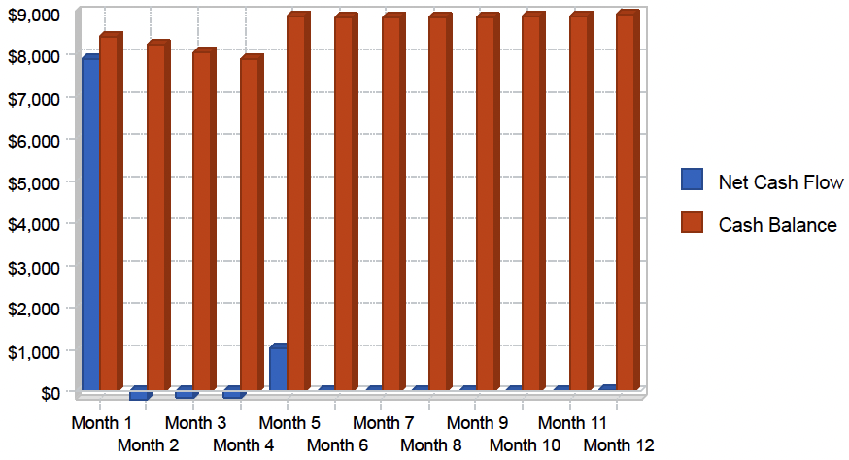

Cash Flow

| **Pro Forma Cash** |  |  |  |
| --- | --- | --- | --- |
| **Cash Received** | **Year 1** | **Year 2** | **Year 3** |
| **Cash from Operations** |  |  |  |
| Cash Sales | $166,400 | $211,022 | $239,975 |
| Subtotal Cash from Operations | $166,400 | $211,022 | $239,975 |
| **Additional Cash Received** |  |  |  |
| Sales Tax, VAT, HST/GST Received | $0 | $0 | $0 |
| New Current Borrowing | $0 | $0 | $0 |
| New Other Liabilities (interest-free) | $0 | $0 | $0 |
| New Long-term Liabilities | $0 | $0 | $0 |
| Sales of Other Current Assets | $0 | $0 | $0 |
| Sales of Long-term Assets | $0 | $0 | $0 |
| New Investment Received | $0 | $0 | $0 |
| Subtotal Cash Received | $166,400 | $211,022 | $239,975 |
| **Expenditures** |  |  |  |
| Expenditures from Operations |  |  |  |
| Cash Spending | $46,400 | $52,520 | $54,876 |
| Bill Payments | $99,540 | $128,730 | $147,285 |
| Subtotal Spent on Operations | $145,940 | $181,250 | $202,161 |
| **Additional Cash Spent** |  |  |  |
| Sales Tax, VAT, HST/GST Paid Out | $0 | $0 | $0 |
| Principal Repayment of Current Borrowing | $0 | $0 | $0 |
| Other Liabilities Principal Repayment | $0 | $0 | $0 |
| Long-term Liabilities Principal Repayment | $12,000 | $12,000 | $12,000 |
| Purchase Other Current Assets | $0 | $0 | $0 |
| Purchase Long-term Assets | $0 | $0 | $0 |
| Dividends | $0 | $0 | $0 |
| Subtotal Cash Spent | $157,940 | $193,250 | $214,161 |
| Net Cash Flow | $8,460 | $17,772 | $25,814 |
| **Cash Balance** | **$8,960** | **$26,733** | **$52,547** |

## 

## Break-even Analysis

The break-even analysis shows that Trend Setters has a good balance of fixed costs and sufficient sales strength to remain healthy. This calculation is focused on service sales, and excludes costs related to product sales. Our conservative forecast shows the salon just passing the break-even point throughout most of the first year, but we expect actual sales to be higher.

Break-even Analysis

## 

| *A tool like [LivePlan](https://www.liveplan.com/features/business-plan-builder?offer=BUS_SAMPLE_HALFOFF&utm_source=bplans.com&utm_medium=download&utm_campaign=sample_plan&utm_content=hairsalon_docx_inline6) can help you create a chart like this and automatically include it in your business plan. |
| --- |

Break-even Analysis

| Monthly Revenue Break-even | $12,995 |
| --- | --- |
| **Assumptions:** |  |
| Average Percent Variable Cost | 3% |
| **Estimated Monthly Fixed Cost** | **$12,657** |

## Projected Profit and Loss

The following table shows our very conservative profit and loss projections for the next three years. The table includes the payments for all independently contracted stylists and technicians, as well for all regularly occurring supply expenses associated with service sales.

Gross Margin Monthly

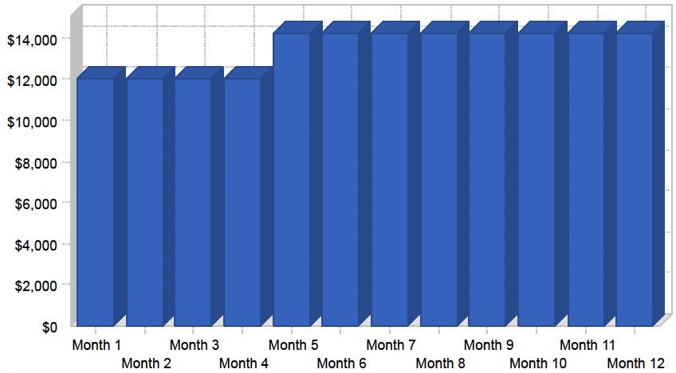

| *A tool like [LivePlan](https://www.liveplan.com/features/business-plan-builder?offer=BUS_SAMPLE_HALFOFF&utm_source=bplans.com&utm_medium=download&utm_campaign=sample_plan&utm_content=hairsalon_docx_inline7) can help you create a chart like this and automatically include it in your business plan. |
| --- |

Gross Margin Yearly

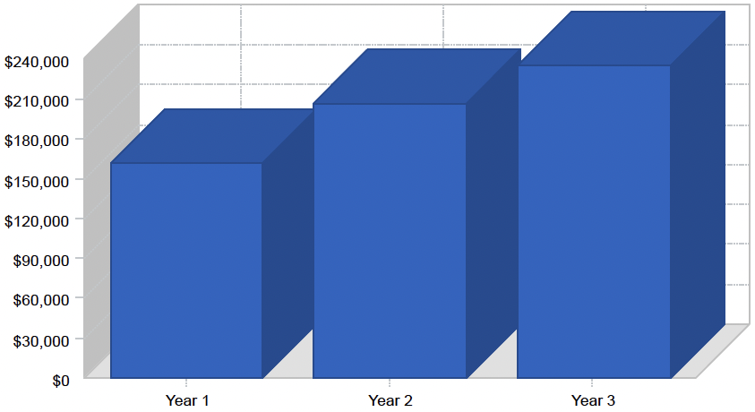

| *A tool like [LivePlan](https://www.liveplan.com/features/business-plan-builder?offer=BUS_SAMPLE_HALFOFF&utm_source=bplans.com&utm_medium=download&utm_campaign=sample_plan&utm_content=hairsalon_docx_inline8) can help you create a chart like this and automatically include it in your business plan. |
| --- |

### 

Profit and Loss

| **Pro Forma Profit and Loss** |  |  |  |
| --- | --- | --- | --- |
|  | **Year 1** | **Year 2** | **Year 3** |
| Sales | $166,400 | $211,022 | $239,975 |
| Direct Cost of Sales | $4,320 | $4,300 | $4,400 |
| Other Costs of Sales | $0 | $0 | $0 |
| Total Cost of Sales | $4,320 | $4,300 | $4,400 |
| Gross Margin | $162,080 | $206,722 | $235,575 |
| Gross Margin % | 97.40% | 97.96% | 98.17% |
| **Expenses** |  |  |  |
| Payroll | $46,400 | $52,520 | $54,876 |
| Marketing/Promotion | $22,800 | $24,000 | $26,000 |
| Depreciation | $8,146 | $8,146 | $8,146 |
| Rent | $22,740 | $22,740 | $22,740 |
| Utilities | $4,200 | $4,200 | $4,200 |
| Insurance | $1,200 | $1,200 | $1,200 |
| Payroll Taxes | $0 | $0 | $0 |
| Independently contracted stylists | $40,400 | $55,000 | $69,000 |
| Supplies | $6,000 | $6,000 | $6,000 |
| Other | $0 | $0 | $0 |
| Total Operating Expenses | $151,886 | $173,806 | $192,162 |
|  |  |  |  |
| Profit Before Interest and Taxes | $10,194 | $32,916 | $43,413 |
| EBITDA | $18,340 | $41,062 | $51,559 |
| Interest Expense | $5,542 | $4,392 | $3,192 |
| Taxes Incurred | $1,396 | $8,557 | $12,066 |
| Net Profit | $3,257 | $19,967 | $28,155 |
| Net Profit/Sales | 1.96% | 9.46% | 11.73% |

### 

Profit Yearly

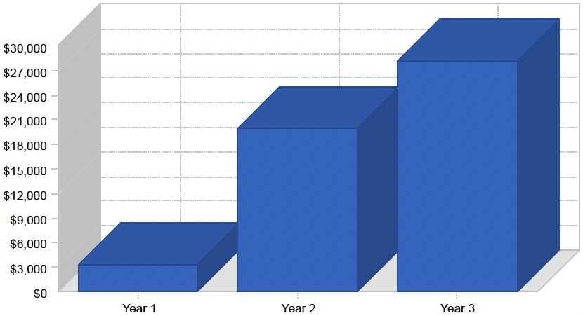

| *A tool like [LivePlan](https://www.liveplan.com/features/business-plan-builder?offer=BUS_SAMPLE_HALFOFF&utm_source=bplans.com&utm_medium=download&utm_campaign=sample_plan&utm_content=hairsalon_docx_inline9) can help you create a chart like this and automatically include it in your business plan. |
| --- |

## 

## Balance Sheet

As shown in the balance sheet, we expect a healthy growth in net worth.

| **Pro Forma Balance Sheet** |  |  |  |
| --- | --- | --- | --- |
| **Assets** | **Year 1** | **Year 2** | **Year 3** |
| **Current Assets** |  |  |  |
| Cash | $8,960 | $26,733 | $52,547 |
| Other Current Assets | $600 | $600 | $600 |
| Total Current Assets | $9,560 | $27,333 | $53,147 |
| Long-term Assets |  |  |  |
| Long-term Assets | $59,500 | $59,500 | $59,500 |
| Accumulated Depreciation | $8,146 | $16,292 | $24,438 |
| Total Long-term Assets | $51,354 | $43,208 | $35,062 |
| Total Assets | $60,914 | $70,541 | $88,209 |
| **Liabilities and Capital** | **Year 1** | **Year 2** | **Year 3** |
| **Current Liabilities** |  |  |  |
| Current Liabilities |  |  |  |
| Accounts Payable | $9,057 | $10,717 | $12,230 |
| Current Borrowing | $0 | $0 | $0 |
| Other Current Liabilities | $0 | $0 | $0 |
| Subtotal Current Liabilities | $9,057 | $10,717 | $12,230 |
| Long-term Liabilities | $49,917 | $37,917 | $25,917 |
| Total Liabilities | $58,974 | $48,634 | $38,147 |
| Paid-in Capital | $500 | $500 | $500 |
| Retained Earnings | ($1,817) | $1,440 | $21,407 |
| Earnings | $3,257 | $19,967 | $28,155 |
| Total Capital | $1,940 | $21,907 | $50,062 |
| **Total Liabilities and Capital** | **$60,914** | **$70,541** | **$88,209** |
|  |  |  |  |
| **Net Worth** | **$1,940** | **$21,907** | **$50,062** |

## Business Ratios

Business ratios for the years of this plan are shown below. Industry profile ratios based on the Standard Industrial Classification (SIC) Index code 7231, Beauty Shops, are shown for comparison.

| **Ratio Analysis** | **Year 1** | **Year 2** | **Year 3** | **Industry Profile** |
| --- | --- | --- | --- | --- |
| Sales Growth | n.a. | 26.82% | 13.72% | 7.35% |
| **Percent of Total Assets** |  |  |  |  |
| Other Current Assets | 0.98% | 0.85% | 0.68% | 50.11% |
| Total Current Assets | 15.69% | 38.75% | 60.25% | 64.74% |
| Long-term Assets | 84.31% | 61.25% | 39.75% | 35.26% |
| Total Assets | 100.00% | 100.00% | 100.00% | 100.00% |
| Current Liabilities | 14.87% | 15.19% | 13.86% | 21.71% |
| Long-term Liabilities | 81.95% | 53.75% | 29.38% | 25.39% |
| Total Liabilities | 96.82% | 68.94% | 43.25% | 47.10% |
| Net Worth | 3.18% | 31.06% | 56.75% | 52.90% |
| **Percent of Sales** |  |  |  |  |
| Sales | 100.00% | 100.00% | 100.00% | 100.00% |
| Gross Margin | 97.40% | 97.96% | 98.17% | 100.00% |
| Selling, General & Administrative Expenses | 95.45% | 88.50% | 86.43% | 67.01% |
| Advertising Expenses | 4.90% | 3.86% | 3.39% | 2.18% |
| Profit Before Interest and Taxes | 6.13% | 15.60% | 18.09% | 4.59% |
| **Main Ratios** |  |  |  |  |
| Current | 1.06 | 2.55 | 4.35 | 1.97 |
| Quick | 1.06 | 2.55 | 4.35 | 1.46 |
| Total Debt to Total Assets | 96.82% | 68.94% | 43.25% | 53.38% |
| Pre-tax Return on Net Worth | 239.86% | 130.21% | 80.34% | 8.92% |
| Pre-tax Return on Assets | 7.64% | 40.44% | 45.60% | 19.14% |
| **Additional Ratios** | **Year 1** | **Year 2** | **Year 3** |  |
| Net Profit Margin | 1.96% | 9.46% | 11.73% | n.a |
| Return on Equity | 167.90% | 91.15% | 56.24% | n.a |
| **Activity Ratios** |  |  |  |  |
| Accounts Payable Turnover | 11.99 | 12.17 | 12.17 | n.a |
| Payment Days | 27 | 28 | 28 | n.a |
| Total Asset Turnover | 2.73 | 2.99 | 2.72 | n.a |

| **Debt Ratios** |  |  |  |  |
| --- | --- | --- | --- | --- |
| Debt to Net Worth | 30.41 | 2.22 | 0.76 | n.a |
| Current Liab. to Liab. | 0.15 | 0.22 | 0.32 | n.a |
| **Liquidity Ratios** |  |  |  |  |
| Net Working Capital | $503 | $16,616 | $40,917 | n.a |
| Interest Coverage | 1.84 | 7.50 | 13.60 | n.a |
| **Additional Ratios** |  |  |  |  |
| Assets to Sales | 0.37 | 0.33 | 0.37 | n.a |
| Current Debt/Total Assets | 15% | 15% | 14% | n.a |
| Acid Test | 1.06 | 2.55 | 4.35 | n.a |
| Sales/Net Worth | 85.79 | 9.63 | 4.79 | n.a |
| **Dividend Payout** | **0.00** | **0.00** | **0.00** | **n.a** |
|  |  |  |  |  |
|  |  |  |  |  |

# **Appendix**

Sales Forecast (With Monthly Detail)

| **Sales** |  | **Month 1** | **Month 2** | **Month 3** | **Month 4** | **Month 5** | **Month 6** | **Month 7** | **Month 8** | **Month 9** | **Month 10** | **Month 11** | **Month 12** |
| --- | --- | --- | --- | --- | --- | --- | --- | --- | --- | --- | --- | --- | --- |
| Owner | 0% | $3,600 | $3,600 | $3,600 | $3,600 | $4,400 | $4,400 | $4,400 | $4,400 | $4,400 | $4,400 | $4,400 | $4,400 |
| Stylist #1 | 0% | $3,600 | $3,600 | $3,600 | $3,600 | $4,400 | $4,400 | $4,400 | $4,400 | $4,400 | $4,400 | $4,400 | $4,400 |
| Barber #1 | 0% | $1,200 | $1,200 | $1,200 | $1,200 | $1,500 | $1,500 | $1,500 | $1,500 | $1,500 | $1,500 | $1,500 | $1,500 |
| Stylist #2 | 0% | $1,700 | $1,700 | $1,700 | $1,700 | $2,000 | $2,000 | $2,000 | $2,000 | $2,000 | $2,000 | $2,000 | $2,000 |
| Stylist #3 | 0% | $0 | $0 | $0 | $0 | $0 | $0 | $0 | $0 | $0 | $0 | $0 | $0 |
| Nails and massage | 0% | $1,500 | $1,500 | $1,500 | $1,500 | $1,500 | $1,500 | $1,500 | $1,500 | $1,500 | $1,500 | $1,500 | $1,500 |
| Product sales | 0% | $800 | $800 | $800 | $800 | $800 | $800 | $800 | $800 | $800 | $800 | $800 | $800 |
| Total Sales |  | $12,400 | $12,400 | $12,400 | $12,400 | $14,600 | $14,600 | $14,600 | $14,600 | $14,600 | $14,600 | $14,600 | $14,600 |
| **Direct Cost of Sales** |  | **Month 1** | **Month 2** | **Month 3** | **Month 4** | **Month 5** | **Month 6** | **Month 7** | **Month 8** | **Month 9** | **Month 10** | **Month 11** | **Month 12** |
| Product Costs |  | $360 | $360 | $360 | $360 | $360 | $360 | $360 | $360 | $360 | $360 | $360 | $360 |
| Other |  | $0 | $0 | $0 | $0 | $0 | $0 | $0 | $0 | $0 | $0 | $0 | $0 |
| **Subtotal Direct Cost of Sales** |  | $360 | $360 | $360 | $360 | $360 | $360 | $360 | $360 | $360 | $360 | $360 | $360 |

Personnel (With Monthly Details)

| **Personnel Plan** |  | **Month 1** | **Month 2** | **Month 3** | **Month 4** | **Month 5** | **Month 6** | **Month 7** | **Month 8** | **Month 9** | **Month 10** | **Month 11** | **Month 12** |
| --- | --- | --- | --- | --- | --- | --- | --- | --- | --- | --- | --- | --- | --- |
| Owner (Stylist) | 0% | $2,000 | $2,000 | $2,000 | $2,000 | $2,000 | $2,000 | $2,000 | $2,000 | $2,000 | $2,000 | $2,000 | $2,000 |
| Receptionist | 0% | $1,200 | $1,200 | $1,200 | $1,200 | $1,200 | $1,200 | $1,200 | $1,200 | $1,200 | $1,200 | $1,200 | $1,200 |
| Shampoo Tech | 0% | $0 | $0 | $0 | $0 | $1,000 | $1,000 | $1,000 | $1,000 | $1,000 | $1,000 | $1,000 | $1,000 |
| Total People |  | 2 | 2 | 2 | 2 | 3 | 3 | 3 | 3 | 3 | 3 | 3 | 3 |
| **Total Payroll** |  | **$3,200** | **$3,200** | **$3,200** | **$3,200** | **$4,200** | **$4,200** | **$4,200** | **$4,200** | **$4,200** | **$4,200** | **$4,200** | **$4,200** |

Profit and Loss Statement (With Monthly Detail)

| **Pro Forma Profit and Loss** |  | **Month 1** | **Month 2** | **Month 3** | **Month 4** | **Month 5** | **Month 6** | **Month 7** | **Month 8** | **Month 9** | **Month 10** | **Month 11** | **Month 12** |
| --- | --- | --- | --- | --- | --- | --- | --- | --- | --- | --- | --- | --- | --- |
| Sales |  | $12,400 | $12,400 | $12,400 | $12,400 | $14,600 | $14,600 | $14,600 | $14,600 | $14,600 | $14,600 | $14,600 | $14,600 |
| Direct Cost of Sales |  | $360 | $360 | $360 | $360 | $360 | $360 | $360 | $360 | $360 | $360 | $360 | $360 |
| Other Costs of Sales |  | $0 | $0 | $0 | $0 | $0 | $0 | $0 | $0 | $0 | $0 | $0 | $0 |
| Total Cost of Sales |  | $360 | $360 | $360 | $360 | $360 | $360 | $360 | $360 | $360 | $360 | $360 | $360 |
| Gross Margin |  | $12,040 | $12,040 | $12,040 | $12,040 | $14,240 | $14,240 | $14,240 | $14,240 | $14,240 | $14,240 | $14,240 | $14,240 |
| Gross Margin % |  | 97.10% | 97.10% | 97.10% | 97.10% | 97.53% | 97.53% | 97.53% | 97.53% | 97.53% | 97.53% | 97.53% | 97.53% |
| **Expenses** |  |  |  |  |  |  |  |  |  |  |  |  |  |
| Payroll |  | $3,200 | $3,200 | $3,200 | $3,200 | $4,200 | $4,200 | $4,200 | $4,200 | $4,200 | $4,200 | $4,200 | $4,200 |
| Marketing/Promotion |  | $1,900 | $1,900 | $1,900 | $1,900 | $1,900 | $1,900 | $1,900 | $1,900 | $1,900 | $1,900 | $1,900 | $1,900 |
| Depreciation |  | $633 | $683 | $683 | $683 | $683 | $683 | $683 | $683 | $683 | $683 | $683 | $683 |
| Rent |  | $1,895 | $1,895 | $1,895 | $1,895 | $1,895 | $1,895 | $1,895 | $1,895 | $1,895 | $1,895 | $1,895 | $1,895 |
| Utilities |  | $350 | $350 | $350 | $350 | $350 | $350 | $350 | $350 | $350 | $350 | $350 | $350 |
| Insurance |  | $100 | $100 | $100 | $100 | $100 | $100 | $100 | $100 | $100 | $100 | $100 | $100 |
| Payroll Taxes | 15% | $0 | $0 | $0 | $0 | $0 | $0 | $0 | $0 | $0 | $0 | $0 | $0 |
| Independently contracted stylists |  | $2,700 | $2,700 | $2,700 | $2,700 | $3,700 | $3,700 | $3,700 | $3,700 | $3,700 | $3,700 | $3,700 | $3,700 |
| Supplies | 15% | $500 | $500 | $500 | $500 | $500 | $500 | $500 | $500 | $500 | $500 | $500 | $500 |
| Other |  | $0 | $0 | $0 | $0 | $0 | $0 | $0 | $0 | $0 | $0 | $0 | $0 |
|  |  |  |  |  |  |  |  |  |  |  |  |  |  |
| Total Operating Expenses |  | $11,278 | $11,328 | $11,328 | $11,328 | $13,328 | $13,328 | $13,328 | $13,328 | $13,328 | $13,328 | $13,328 | $13,328 |
|  |  |  |  |  |  |  |  |  |  |  |  |  |  |
| Profit Before Interest and Taxes |  | $762 | $712 | $712 | $712 | $912 | $912 | $912 | $912 | $912 | $912 | $912 | $912 |
| EBITDA |  | $1,395 | $1,395 | $1,395 | $1,395 | $1,595 | $1,595 | $1,595 | $1,595 | $1,595 | $1,595 | $1,595 | $1,595 |
| Interest Expense |  | $508 | $499 | $491 | $483 | $474 | $466 | $458 | $449 | $441 | $433 | $424 | $416 |
| Taxes Incurred |  | $76 | $64 | $66 | $69 | $131 | $134 | $136 | $139 | $141 | $144 | $146 | $149 |
|  |  |  |  |  |  |  |  |  |  |  |  |  |  |
| Net Profit |  | $178 | $149 | $155 | $161 | $306 | $312 | $318 | $324 | $330 | $336 | $341 | $347 |
| **Net Profit/Sales** |  | **1.44%** | **1.20%** | **1.25%** | **1.29%** | **2.10%** | **2.14%** | **2.18%** | **2.22%** | **2.26%** | **2.30%** | **2.34%** | **2.38%** |

Cash Flow Statement (With Monthly Detail)  
Pro Forma Cash Flow

| **Cash Received** |  | **Month 1** | **Month 2** | **Month 3** | **Month 4** | **Month 5** | **Month 6** | **Month 7** | **Month 8** | **Month 9** | **Month 10** | **Month 11** | **Month 12** |
| --- | --- | --- | --- | --- | --- | --- | --- | --- | --- | --- | --- | --- | --- |
| **Cash from Operations** |  |  |  |  |  |  |  |  |  |  |  |  |  |
| Cash Sales |  | $12,400 | $12,400 | $12,400 | $12,400 | $14,600 | $14,600 | $14,600 | $14,600 | $14,600 | $14,600 | $14,600 | $14,600 |
| Subtotal Cash from Operations |  | $12,400 | $12,400 | $12,400 | $12,400 | $14,600 | $14,600 | $14,600 | $14,600 | $14,600 | $14,600 | $14,600 | $14,600 |
| **Additional Cash Received** |  |  |  |  |  |  |  |  |  |  |  |  |  |
| Sales Tax, VAT, HST/GST Received | 0.00% | $0 | $0 | $0 | $0 | $0 | $0 | $0 | $0 | $0 | $0 | $0 | $0 |
| New Current Borrowing |  | $0 | $0 | $0 | $0 | $0 | $0 | $0 | $0 | $0 | $0 | $0 | $0 |
| New Other Liabilities (interest-free) |  | $0 | $0 | $0 | $0 | $0 | $0 | $0 | $0 | $0 | $0 | $0 | $0 |
| New Long-term Liabilities |  | $0 | $0 | $0 | $0 | $0 | $0 | $0 | $0 | $0 | $0 | $0 | $0 |
| Sales of Other Current Assets |  | $0 | $0 | $0 | $0 | $0 | $0 | $0 | $0 | $0 | $0 | $0 | $0 |
| Sales of Long-term Assets |  | $0 | $0 | $0 | $0 | $0 | $0 | $0 | $0 | $0 | $0 | $0 | $0 |
| New Investment Received |  | $0 | $0 | $0 | $0 | $0 | $0 | $0 | $0 | $0 | $0 | $0 | $0 |
| Subtotal Cash Received |  | $12,400 | $12,400 | $12,400 | $12,400 | $14,600 | $14,600 | $14,600 | $14,600 | $14,600 | $14,600 | $14,600 | $14,600 |

| **Expenditures** | **Month 1** | **Month 2** | **Month 3** | **Month 4** | **Month 5** | **Month 6** | **Month 7** | **Month 8** | **Month 9** | **Month 10** | **Month 11** | **Month 12** |
| --- | --- | --- | --- | --- | --- | --- | --- | --- | --- | --- | --- | --- |
| **Expenditures from Operations** |  |  |  |  |  |  |  |  |  |  |  |  |
| Cash Spending | $3,200 | $3,200 | $3,200 | $3,200 | $4,200 | $4,200 | $4,200 | $4,200 | $4,200 | $4,200 | $4,200 | $4,200 |
| Bill Payments | $280 | $8,388 | $8,368 | $8,362 | $8,392 | $9,410 | $9,405 | $9,399 | $9,393 | $9,387 | $9,381 | $9,375 |
| Subtotal Spent on Operations | $3,480 | $11,588 | $11,568 | $11,562 | $12,592 | $13,610 | $13,605 | $13,599 | $13,593 | $13,587 | $13,581 | $13,575 |
| **Additional Cash Spent** |  |  |  |  |  |  |  |  |  |  |  |  |
| Sales Tax, VAT, HST/GST Paid Out | $0 | $0 | $0 | $0 | $0 | $0 | $0 | $0 | $0 | $0 | $0 | $0 |
| Principal Repayment of Current Borrowing | $0 | $0 | $0 | $0 | $0 | $0 | $0 | $0 | $0 | $0 | $0 | $0 |
| Other Liabilities Principal Repayment | $0 | $0 | $0 | $0 | $0 | $0 | $0 | $0 | $0 | $0 | $0 | $0 |
| Long-term Liabilities Principal Repayment | $1,000 | $1,000 | $1,000 | $1,000 | $1,000 | $1,000 | $1,000 | $1,000 | $1,000 | $1,000 | $1,000 | $1,000 |
| Purchase Other Current Assets | $0 | $0 | $0 | $0 | $0 | $0 | $0 | $0 | $0 | $0 | $0 | $0 |
| Purchase Long-term Assets | $0 | $0 | $0 | $0 | $0 | $0 | $0 | $0 | $0 | $0 | $0 | $0 |
| Dividends | $0 | $0 | $0 | $0 | $0 | $0 | $0 | $0 | $0 | $0 | $0 | $0 |
| Subtotal Cash Spent | $4,480 | $12,588 | $12,568 | $12,562 | $13,592 | $14,610 | $14,605 | $14,599 | $14,593 | $14,587 | $14,581 | $14,575 |
| Net Cash Flow | $7,920 | ($188) | ($168) | ($162) | $1,008 | ($10) | ($5) | $1 | $7 | $13 | $19 | $25 |
| **Cash Balance** | $8,420 | $8,232 | $8,064 | $7,902 | $8,911 | $8,900 | $8,896 | $8,897 | $8,904 | $8,917 | $8,935 | $8,960 |

Balance Sheet (With Monthly Detail)  
Pro Forma Balance Sheet

| **Assets** | **Stating Balances** | **Month 1** | **Month 2** | **Month 3** | **Month 4** | **Month 5** | **Month 6** | **Month 7** | **Month 8** | **Month 9** | **Month 10** | **Month 11** | **Month 12** |
| --- | --- | --- | --- | --- | --- | --- | --- | --- | --- | --- | --- | --- | --- |
| **Current Assets** |  |  |  |  |  |  |  |  |  |  |  |  |  |
| Cash | $500 | $8,420 | $8,232 | $8,064 | $7,902 | $8,911 | $8,900 | $8,896 | $8,897 | $8,904 | $8,917 | $8,935 | $8,960 |
| Other Current Assets | $600 | $600 | $600 | $600 | $600 | $600 | $600 | $600 | $600 | $600 | $600 | $600 | $600 |
| Total Current Assets | $1,100 | $9,020 | $8,832 | $8,664 | $8,502 | $9,511 | $9,500 | $9,496 | $9,497 | $9,504 | $9,517 | $9,535 | $9,560 |
| **Long-term Assets** |  |  |  |  |  |  |  |  |  |  |  |  |  |
| Long-term Assets | $59,500 | $59,500 | $59,500 | $59,500 | $59,500 | $59,500 | $59,500 | $59,500 | $59,500 | $59,500 | $59,500 | $59,500 | $59,500 |
| Accumulated Depreciation | $0 | $633 | $1,316 | $1,999 | $2,682 | $3,365 | $4,048 | $4,731 | $5,414 | $6,097 | $6,780 | $7,463 | $8,146 |
| Total Long-term Assets | $59,500 | $58,867 | $58,184 | $57,501 | $56,818 | $56,135 | $55,452 | $54,769 | $54,086 | $53,403 | $52,720 | $52,037 | $51,354 |
| Total Assets | $60,600 | $67,887 | $67,016 | $66,165 | $65,320 | $65,646 | $64,952 | $64,265 | $63,583 | $62,907 | $62,237 | $61,572 | $60,914 |

| **Liabilities and Capital** |  | **Month 1** | **Month 2** | **Month 3** | **Month 4** | **Month 5** | **Month 6** | **Month 7** | **Month 8** | **Month 9** | **Month 10** | **Month 11** | **Month 12** |
| --- | --- | --- | --- | --- | --- | --- | --- | --- | --- | --- | --- | --- | --- |
| **Current Liabilities** |  |  |  |  |  |  |  |  |  |  |  |  |  |
| Accounts Payable | $0 | $8,109 | $8,089 | $8,084 | $8,078 | $9,097 | $9,091 | $9,086 | $9,080 | $9,074 | $9,069 | $9,063 | $9,057 |
| Current Borrowing | $0 | $0 | $0 | $0 | $0 | $0 | $0 | $0 | $0 | $0 | $0 | $0 | $0 |
| Other Current Liabilities | $0 | $0 | $0 | $0 | $0 | $0 | $0 | $0 | $0 | $0 | $0 | $0 | $0 |
| Subtotal Current Liabilities | $0 | $8,109 | $8,089 | $8,084 | $8,078 | $9,097 | $9,091 | $9,086 | $9,080 | $9,074 | $9,069 | $9,063 | $9,057 |
| Long-term Liabilities | $61,917 | $60,917 | $59,917 | $58,917 | $57,917 | $56,917 | $55,917 | $54,917 | $53,917 | $52,917 | $51,917 | $50,917 | $49,917 |
| Total Liabilities | $61,917 | $69,026 | $68,006 | $67,001 | $65,995 | $66,014 | $65,008 | $64,003 | $62,997 | $61,991 | $60,986 | $59,980 | $58,974 |
| Paid-in Capital | $500 | $500 | $500 | $500 | $500 | $500 | $500 | $500 | $500 | $500 | $500 | $500 | $500 |
| Retained Earnings | ($1,817) | ($1,817) | ($1,817) | ($1,817) | ($1,817) | ($1,817) | ($1,817) | ($1,817) | ($1,817) | ($1,817) | ($1,817) | ($1,817) | ($1,817) |
| Earnings | $0 | $178 | $327 | $482 | $642 | $949 | $1,261 | $1,579 | $1,903 | $2,232 | $2,568 | $2,909 | $3,257 |
| Total Capital | ($1,317) | ($1,139) | ($990) | ($835) | ($675) | ($368) | ($56) | $262 | $586 | $915 | $1,251 | $1,592 | $1,940 |
| Total Liabilities and Capital | $60,600 | $67,887 | $67,016 | $66,165 | $65,320 | $65,646 | $64,952 | $64,265 | $63,583 | $62,907 | $62,237 | $61,572 | $60,914 |
| **Net Worth** | **($1,317)** | **($1,139)** | **($990)** | **($835)** | **($675)** | **($368)** | **($56)** | **$262** | **$586** | **$915** | **$1,251** | **$1,592** | **$1,940** |

Next Steps  
Applying for funding?

You’ll want to be sure your pitch and finished plan are well thought through and accurate, and that you’ve thought through questions a lender might ask. LivePlan’s step-by-step guidance, automated financials, expert support, and visual charts and graphs will help you write a business plan that'll maximize your chances of securing funding. Your finished plan will be in a format lenders and investors will expect to see, and you’ll be able to confidently answer any question they may ask. [**Learn more →**](https://www.liveplan.com/secure-funding?offer=BUS_SAMPLE_HALFOFF&utm_source=bplans.com&utm_medium=download&utm_campaign=sample_plan&utm_content=hairsalon_docx_inline10)

Validating a business idea?

You likely don’t have any historical data yet so you’ll want to be sure you’ve put some serious thought into all the factors going into your plan and forecast. Ensure that you’ve thoroughly thought through your target market and the problem you’re solving as well as your business model and financials. Also, make sure you’re going out into the world and talking to your potential customers! LivePlan will help you forecast your revenue to see if your idea is financially sound and provide competitor benchmarks for the ultimate reality check. [**Learn more →**](https://www.liveplan.com/the-growth-planning-process-for-ideas?offer=BUS_SAMPLE_HALFOFF&utm_source=bplans.com&utm_medium=download&utm_campaign=sample_plan&utm_content=hairsalon_docx_inline11)

Growing your business?

You’ll want to compare your forecast to your actual business performance (plan vs. actuals). Doing so will help you spot where your forecast was accurate (or off), and determine opportunities for growth. LivePlan's Dashboard easily connects with [QuickBooks or Xero](https://www.liveplan.com/integrations?offer=BUS_SAMPLE_HALFOFF&utm_source=bplans.com&utm_medium=download&utm_campaign=sample_plan&utm_content=hairsalon_docx_inline12) to give you a detailed look at how your actual revenue measures up to projections, so you can make informed business decisions with confidence. [**Learn more →**](https://www.liveplan.com/features/financial-forecasts-and-scenarios?offer=BUS_SAMPLE_HALFOFF&utm_source=bplans.com&utm_medium=download&utm_campaign=sample_plan&utm_content=hairsalon_docx_inline13)

| **⭐️Pro Tip:** If you haven’t already - be sure to go back and finish your Executive Summary (which we recommended you save for last). |
| --- |

[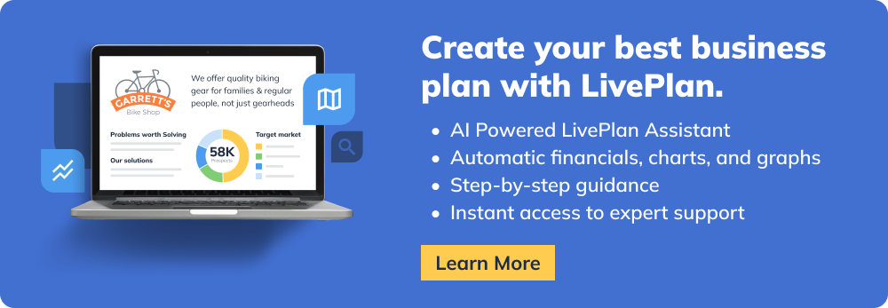](http://www.liveplan.com?offer=BUS_SAMPLE_HALFOFF&utm_source=bplans.com&utm_medium=download&utm_campaign=sample_plan&utm_content=hairsalon_docx_ad6)